**Chapter 1**

**Preamble**

**1.1 Introduction**

Mel-Frequency Cepstral Coefficients (MFCC) are widely used in speech and audio signal processing. They help in extracting key features from a sound signal by transforming it into a representation that mimics human auditory perception. The main idea behind MFCC is to analyze the frequency content of a signal using the Mel scale, which reflects how humans perceive different frequencies.

MFCC is commonly used in speech recognition, speaker identification, music classification, and emotion detection. It provides a compact representation of the spectral properties of an audio signal, making it useful for machine learning and artificial intelligence applications.By converting a sound signal into a set of numerical coefficients, MFCC allows computers to recognize and differentiate between various speech patterns and sounds effectively**.**

MFCC stands for Mel-frequency Cepstral Coefficients. It’s a feature used in automatic speech and speaker recognition. Essentially, it’s a way to represent the short-term power spectrum of a sound which helps machines understand and process human speech more effectively. Imagine your voice as a unique fingerprint. MFCCs, function similarly to a unique code capturing the salient features of your speech and enabling computers to discern between distinct words, and sounds. In speech recognition applications where computers must translate spoken words into text this code is especially helpful.

**Role of Mel-Frequency Cepstral Coefficients (MFCCs**)

MFCCs are mathematical representations of the vocal tract produced by humans as they speak. The process involves several steps to capture the essential characteristics of human speech which are most discernible to the human ear.

**1.2 Scope**

**1**. **Speech and Speaker Recognition**

One of the most common applications of MFCC is in automatic speech recognition (ASR) systems. Companies like Google, Amazon, and Apple use MFCC-based techniques in their voice assistants (Google Assistant, Alexa, Siri). The key advantages include:

* Language Independence: Works with multiple languages.
* Noise Robustness: Effective in noisy environments with proper feature enhancement.
* High Accuracy: Helps in phoneme-based recognition for better speech understanding.
* MFCC is also used in speaker verification and identification systems for biometric security.
* It helps differentiate voices by analyzing unique vocal tract characteristics.

**2.Emotion Recognition and Sentiment Analysis**

MFCC is widely used in emotion recognition systems, which help in applications such as:

* Human-Computer Interaction (HCI): AI systems can detect emotions based on speech patterns.
* Human-Computer Interaction (HCI): AI systems can detect emotions based on speech patterns.
* Mental Health Monitoring: Detecting depression or stress based on voice tone.
* Call Center Analytics: Understanding customer satisfaction levels using speech emotion analysis. Deep learning models, such as CNNs and RNNs, use MFCC as an input feature for emotion classification tasks.

**3. Music and Audio Classification**

MFCC is useful in music genre classification, instrument recognition, and audio fingerprinting. Applications include:

* Music Streaming Services: Platforms like Spotify and YouTube Music use MFCC-based models to classify and recommend songs.
* Sound Event Detection: Identifying environmental sounds like alarms, footsteps, or machinery noise.
* Forensic Audio Analysis: Recognizing speaker identities in legal cases.
* MFCC helps extract features that distinguish between different sounds and musical instruments.

**4. Biomedical and Healthcare Applications**

In healthcare, MFCC is used for analyzing biomedical signals such as:

* Parkinson’s Disease Detection: Voice abnormalities in patients can be identified using MFCC-based models.
* Sleep Apnea Detection: Analyzing snoring and breathing patterns.
* Heart Sound Classification: Detecting abnormalities in heartbeat sounds.
* These applications assist in early diagnosis and monitoring of health conditions.

**5.Robotics and IoT Devices**

Voice-controlled robots and IoT devices rely on MFCC for speech command recognition. Examples include:

* Home Automation: Controlling smart home devices using voice commands.
* Autonomous Vehicles: Voice-based interactions in cars.
* Industrial Automation: Speech-controlled machinery in factories.
* MFCC helps in building efficient and responsive voice-controlled systems

**1.3 Advantages and Disadvantages**

**Advantages:**

**1. Efficient Representation of Speech Features**

MFCC mimics human auditory perception by using the Mel scale, which gives more importance to lower frequencies. This allows it to extract useful speech features while reducing unnecessary data.

**2. Efficient Representation of Speech Features**

MFCC mimics human auditory perception by using the Mel scale, which gives more importance to lower frequencies. This allows it to extract useful speech features while

**3. Computationally Efficient**

Compared to other feature extraction methods like wavelet transforms, MFCC is computationally efficient and can be implemented in real-time speech applications.

**4. Effective for Speaker and Emotion Recognition**

MFCC captures speech characteristics unique to an individual’s vocal tract, making it suitable for biometric authentication and emotion recognition.

**5. Robust for Isolated Word Recognition**

MFCC works well in isolated word recognition tasks, where a single word or phrase is spoken clearly. It is commonly used in voice command applications, such as:

Smart home automation ,Voice-controlled robots and industrial machines.

**Disadvantages**

**1. Sensitivity to Noise**

MFCC is highly sensitive to background noise, which affects its performance in real-world environments like crowded places or noisy streets.

**2. Loss of Temporal Information**

MFCC extracts spectral features but does not preserve time-domain (temporal) information, which is important for speech patterns and phoneme transitions.

**3. Limited Performance in Emotional Speech Recognition**

MFCC is primarily designed for speaker-independent speech recognition, meaning it focuses more on linguistic content than vocal emotion.

**4. Poor Performance in Speaker Recognition Over Long Periods**

MFCC features are based on the short-term spectral envelope, making them unreliable for long

### 1.4 Organization of Report

**Chapter 1:** Preamble, this chapter provides the introduction of the seminar and discusses the scope of the topic Advantages and disadvantages, this chapter gives a brief about the advantages and disadvantages of the MFCC

**Chapter 2:** Literature survey, this chapter gives a summary of the paper used for reference and explains the evolution of concept and how it contributed to the making of the seminar topic and the ideas took from different papers.

**Chapter 3:** Technology, this chapter elaborates the process behind the concept in detail and provides insight into the making of the concept.

**Chapter 4:** Applications, in this chapter it discussed the output rather than the results obtained after the completion of the concept with the efficiency or the accuracy of making correct prediction by the concept.

**Chapter 5:** Conclusion and Future scope and bibliography, here it provides the conclusion obtained by the concept with the future scope which tries to cover the probable loopholes in

the concept that may occur in the future, as the scenario of the future may be different as compared to now.

**Chapter 6:** Bibliography, in this chapter the simple bibliography provides references to books, research papers, and websites related to the seminar topic of Plastic Solar Cells.

**Chapter 2Bottom of Form**

**Related Work or Literature Survey**

**2.1 Evolution of concept**

Mel-Frequency Cepstral Coefficients (MFCC) have evolved over time, adapting to advancements in speech processing, artificial intelligence, and deep learning. Initially designed for speech recognition, MFCC has found applications in speaker identification, music analysis, emotion recognition, and biomedical signal processing. Below is a detailed timeline of its evolution.

**1. Early Speech Processing(pre-1980s)**

* 1940s-1950s: Development of Fourier Transform (FT) and Spectrograms for analyzing speech signals.
* 1960s-1970s: Linear Predictive Coding (LPC) introduced for speech compression and synthesis but lacked perceptual modeling.

**2. Introduction of the Mel Scale and MFCC (1980-1990)**

* 1980: Researchers introduced the Mel scale, which modeled human auditory perception more accurately.
* 1985: Development of Mel Filter Banks to group frequencies based on human hearing sensitivity.
* 1988-1989: MFCC was introduced as a feature extraction method in speech recognition, combining Mel filtering with cepstral analysis.

**3.Adoption and Refinement of MFCC (1990-2000)**

* 1990-1995: MFCC became the standard feature extraction technique in Automatic Speech Recognition (ASR).
* 1995-1999: Introduction of Delta and Delta-Delta Coefficients to capture temporal variations in speech.

**4. Enhancements and Robustness Improvements (2000-2010)**

* 2000-2005: Development of noise-robust MFCC variants, improving speech recognition in real-world environments.
* 2006-2009: MFCC used in biometric authentication systems and music classification applications.

**5. Integration with Deep Learning (2010-2020)**

* 2010-2015: MFCC became the primary input for deep learning models like CNNs and RNNs in speech processing.
* 2016-2019: Researchers explored self-supervised learning models (e.g., Wav2Vec, HuBERT) that still relied on MFCC as a fundamental feature.

**6.Advanced AI & Beyond MFCC (2020-present)**

* 2020-2024: MFCC remains widely used in AI-driven speech recognition, though raw waveform-based approaches (like Wav2Vec 2.0) are emerging as alternatives.
* 2025 & Beyond: Continuous improvements in speech representation learning are expected, but MFCC remains a foundational technique in signal processing.

**2.2 Literature Survey**

speech processing has been an active area of research for several decades, with applications ranging from automatic speech recognition (ASR) to biometric authentication and music classification. One of the most widely used techniques in this field is Mel-Frequency Cepstral Coefficients (MFCC), which extracts speech features based on human auditory perception. Several studies have explored the development, improvements, and applications of MFCC in various domains.

Early speech processing techniques relied on Fourier Transform (FT) and Linear Predictive Coding (LPC) for spectral analysis. However, these approaches did not accurately model the way humans perceive sound frequencies. To address this limitation, Davis and Mermelstein (1980) introduced MFCC, which incorporated Mel-scale filtering to better represent human auditory characteristics. This breakthrough significantly improved speech recognition accuracy, leading to widespread adoption in ASR systems. Furui (1986) further enhanced MFCC by introducing cepstral coefficients, which allowed better speech feature extraction and noise reduction. By the 1990s, Rabiner (1989) and Reynolds (1995) demonstrated that MFCC was highly effective in continuous speech recognition and speaker verification, making it a standard feature extraction method in Hidden Markov Model (HMM)-based and Gaussian Mixture Model (GMM)-based systems.

Traditional MFCC was found to be sensitive to noise, reducing its reliability in real-world environments. To address this issue, researchers proposed noise-robust MFCC variants. Sahidullah and Saha (2012) introduced Modified MFCC (MMFCC), which enhanced speech feature extraction under noisy conditions. Similarly, Young et al. (2015) proposed Wavelet-based MFCC, which improved speech recognition performance in low signal-to-noise ratio (SNR) environments. These advancements made MFCC more applicable to mobile and real-time speech processing systems.

MFCC has been widely used in neural network architectures. Abdel-Hamid et al. (2014) integrated MFCC into Convolutional Neural Networks (CNNs) for improved speech recognition, while Baevski et al. (2020) introduced Wav2Vec, a self-supervised learning model that still relied on MFCC for feature extraction. These developments highlighted the continued importance of MFCC, even as deep learning models evolved toward end-to-end raw waveform processing.

Beyond speech recognition, MFCC has been applied to various fields. In biometric security, Reynolds (1995) demonstrated its effectiveness in speaker identification and voice authentication systems. In music classification, Tzanetakis and Cook (2002) used MFCC to categorize musical genres based on spectral features. In healthcare, Wen et al. (2018) applied MFCC for early detection of Parkinson’s disease through voice analysis. These studies indicate that MFCC remains a versatile feature extraction method, widely used across different industries.

**Chapter 3**

**Methodology**

**3.1 Technologies Used**

MFCC is widely used in speech processing applications and relies on various technologies for feature extraction, processing, and analysis. Below are the key technologies used in MFCC implementation:

**1. Digital Signal Processing (DSP) Techniques**

* Fast Fourier Transform (FFT): Converts the time-domain speech signal into the frequency domain for spectral analysis.
* Mel Filter Bank Processing: Applies a set of triangular filters on the frequency spectrum to mimic human auditory perception.
* Discrete Cosine Transform (DCT): Reduces correlation between features, making them more suitable for classification.
* Cepstral Mean Normalization (CMN): Helps remove channel effects and noise from speech signals.

**2. Machine Learning & Deep Learning Frameworks**

* Hidden Markov Models (HMM): Used in early speech recognition systems, utilizing MFCC as the primary feature set.
* Gaussian Mixture Models (GMM): Applied in speaker recognition and verification tasks based on MFCC

**3.2 Feature Extraction**



Speech input

Pre- Emphasis

Framing

Window ing

Fast Fourier Transform

Mel Filter bank

DCT

Delta Energy

Output

**Fig 3.2.1: Block Diagram of MFCC**

The most commonly used acoustic features are Mel-scale frequency cepstral coefficients. Explanation of step by step computation of MFCC is given below:-

1. **Pre-Emphasis**- In this step isolated word sample is passed through a filter which emphasizes higher frequencies. It will increase the energy of signal at higher frequency.

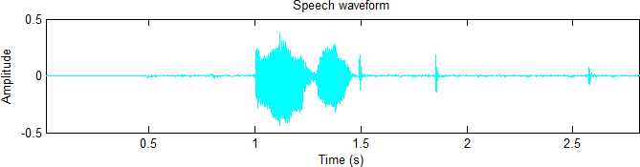

**Fig.3.2.2: Speech waveform**

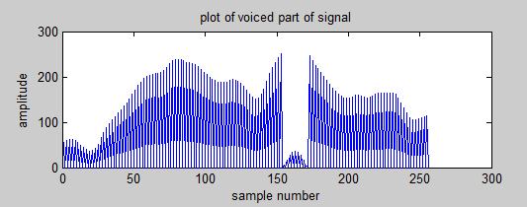

**Fig.3.2.3: Plot of voiced part of signal**

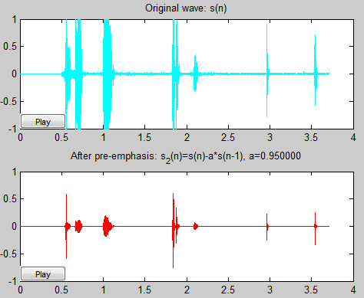

**Fig 3.2.4: Pre-Emphasis**

**1.Frame blocking**: The speech signal is segmented into small duration blocks of 20-30 ms known as frames. Voice signal is divided into N samples and adjacent frames are being separated by M (M<N). Typical values for M=100 and N=256. Framing is required as speech is a time varying signal but when it is examined over a sufficiently short period of time, its properties are fairly stationary.Therefore short time spectral analysis is done.

**2.Hamming Windowing**: Each of the above frames is multiplied with a hamming window in order to keep continuity of the signal. So to reduce this discontinuity we apply window function. Basically the spectral distortion is minimized by using window to taper the voice sample to zero at both beginning and end of each frame.

Y (n) = X (n) * W (n)

Where W (n) is the window function.

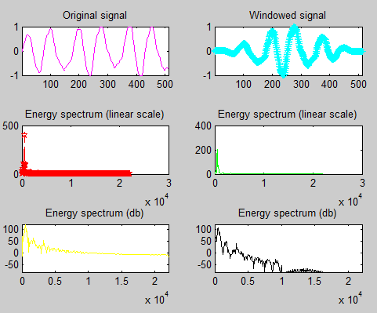

**Fig 3.2.5: Edges become sharp by using Hamming Window**

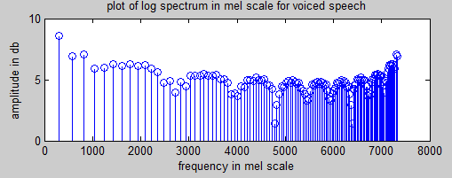**4.Fast Fourier Transform**: FFT is a process of converting time domain into frequency domain. To obtain the magnitude frequency response of each frame we perform FFT. By applying FFT the output is a spectrum or periodogram

**Fig 3.2.6 Spectrum of voiced speech**

**5.Triangular band pass filters**: We multiply magnitude frequency response by a set of 20 triangular band pass filters in order to get smooth magnitude spectrum. It also reduces the size of features involved.

Mel (f) =1125* ln (1+f/700)

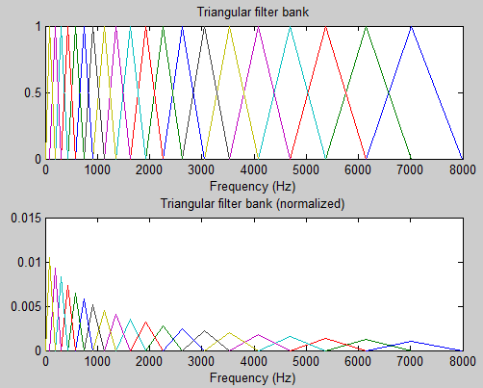

**Fig 3.2.7: Normalizing features**

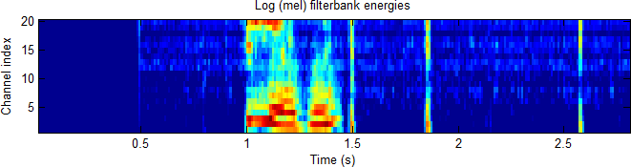

**Fig 3.2.8: Plot of filter bank energies**

**6.Discrete cosine transform**: We apply DCT on the 20log energy 𝐸𝑘 obtained from the triangular band pass filters to have L Mel-scale cepstral coefficients. DCT formula is shown below

Cm=∑ 𝑁cos [m*(k-0.5)*π/N]*𝐸𝑘,m=1,2……L

𝑘=1

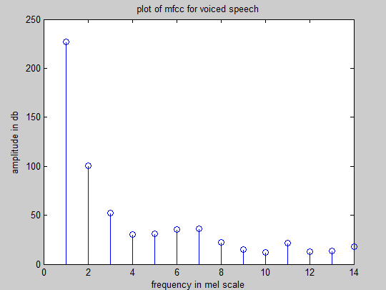Where N = number of triangular band pass filters, L = number of Mel-scale cepstral coefficients. Usually N=20 and L=12. DCT transforms the frequency domain into a time-like domain called quefrency domain. These features are referred to as the Mel-scale cepstral Co-efficients.We can use MFCC alone for speech recognition but for better performance, we can add the log energy and can perform delta operation.

**Fig 3.2.9: Plot of MFCC coefficients**

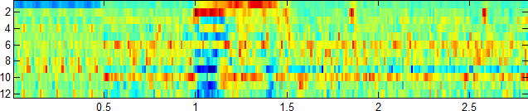

**Fig 3.2.10: Plot of Mel frequency Cepstral**

1. **Log energy**: We can also calculate energy within a frame. It can be another feature to MFCC.
2. **Delta cepstral**: We can add some other features by calculating time derivatives of (energy + MFCC) which give velocity and acceleration.

∆ 𝐶𝑚 (t) =[∑𝜏 =−𝑀𝑀𝐶𝑚 (t+𝜏)𝜏]/[∑𝜏 =−𝑀𝑀𝜏2]

Value for M=2, if we add the velocity, feature dimension is 26. If we add both acceleration and velocity, the feature dimension is 39.

**Chapter 4**

**Applications**

Mel-Frequency Cepstral Coefficients (MFCC) are widely used in speech processing, speaker identification, music classification, healthcare, and artificial intelligence. Below are the key applications with detailed explanations**.**

**1. Speech Recognition**

MFCC is the most commonly used feature extraction method in speech-to-text systems. It helps convert spoken words into a format that AI models can understand.

**Examples:**

1. Voice Assistants: Google Assistant, Amazon Alexa, and Apple Siri use MFCC for recognizing spoken commands.
2. Real-Time Transcription: Applications like Google Speech-to-Text and Microsoft Azure Speech Services use MFCC to convert speech into text.
3. Call Center Automation: AI-powered customer service agents use MFCC for automatic call handling.

**2. Speaker Identification and Verification**

MFCC is used to identify and verify speakers based on their unique voice characteristics.

**Examples:**

1. Voice-Based Login Systems: Used in banking and cybersecurity for authentication.
2. Forensic Voice Matching: Law enforcement agencies use MFCC to analyze suspect recordings.
3. Telephone Authentication: Banks use MFCC-powered voice recognition for customer verification.

**3. Emotion Recognition in Speech**

MFCC is used to analyze emotions in speech by extracting features related to tone, pitch, and intensity.

**Examples:**

1. Customer Sentiment Analysis: Call centers use MFCC to detect if a customer is angry, happy, or frustrated.
2. Mental Health Monitoring: AI models analyze speech patterns for signs of stress, depression, or anxiety.
3. Human-Computer Interaction (HCI): AI-powered chatbots adjust responses based on user emotions.

**4. Music and Audio Classification**

MFCC is used in music information retrieval to classify songs by genre and identify musical instruments

**Examples:**

1. Spotify and YouTube Music: Use MFCC to recommend songs based on user preferences.
2. Shazam: Uses MFCC to identify songs from short audio clips.
3. Sound Event Recognition: Recognizing sounds like alarms, sirens, or wildlife sounds.

**5. Biomedical and Healthcare Applications**

MFCC is used to detect diseases based on voice and heart sounds.

**Examples:**

1. Parkinson’s Disease Detection: Identifies speech abnormalities in Parkinson’s patients.
2. Sleep Apnea Detection: Analyzes breathing patterns and snoring sounds.
3. Heart Sound Classification: Helps in diagnosing heart conditions using MFCC-extracted features from stethoscope recordings.

**6. Security and Surveillance**

MFCC is used in security systems to detect suspicious sounds and speech patterns.

Examples:

1. Gunshot and Explosion Detection: AI-powered security systems use MFCC to identify emergency sounds.
2. Forensic Audio Analysis: Used in court cases to verify voices in recorded conversations.
3. Surveillance Monitoring: Detecting abnormal sounds like screams or alarms.

**7. Robotics and IoT (Internet of Things)**

MFCC is widely used in smart home devices, robotics, and IoT-based applications for voice recognition.

**Examples:**

1. Smart Home Automation: Devices like Google Nest and Amazon Echo use MFCC for voice commands.
2. Industrial Automation: Factories use voice-controlled robots for hands-free machine operation.
3. Autonomous Vehicles: Cars use MFCC for voice-activated controls.

**Chapter 5**

**Conclusion**

Mel-Frequency Cepstral Coefficients (MFCC) have played a significant role in speech processing, speaker recognition, and audio classification for several decades. The technique, inspired by human auditory perception, has been widely adopted due to its ability to effectively capture speech features. By applying Fast Fourier Transform (FFT), Mel-scale filtering, and Discrete Cosine Transform (DCT), MFCC provides a compact and reliable representation of speech signals. Its integration with machine learning and deep learning models has further enhanced its applications in automatic speech recognition (ASR), biometric authentication, music classification, and healthcare.

MFCC has certain limitations**,** such as sensitivity to noise and difficulty in capturing long-term speech variations. To address these challenges, researchers have introduced noise-robust MFCC variants and explored hybrid approaches that integrate MFCC with wavelet transforms, deep learning-based spectrogram analysis, and end-to-end speech processing models. These advancements have improved the robustness and accuracy of speech recognition in real-world environments.

With the evolution of AI-driven speech processing technologies, such as CNNs, RNNs, and Transformer-based architectures, MFCC continues to be a fundamental feature extraction method. While modern deep learning models are shifting towards raw waveform-based learning (e.g., Wav2Vec, HuBERT), MFCC remains relevant due to its efficiency, low computational cost, and effectiveness in resource-constrained applications.

.

**Chapter 6**

**Bibliography**

**1**. Z. Kh. Abdul, et al., "Mel-Frequency Cepstral Coefficient and its Applications: A Review," Chemistry of Materials, vol. 23, no. 2, pp. 470–482, 2011.

**2**. A. M. Rahmani, et al., "Enhanced Heart Sound Classification Using Mel Frequency Cepstral Coefficients and Comparative Analysis of Single vs. Ensemble Classifier Strategies," PLOS ONE, vol. 16, no. 6, pp. e0253345, 2021.

**3**. F. Wolf-Monheim, "Spectral and Rhythm Features for Audio Classification with Deep Convolutional Neural Networks," arXiv preprint arXiv:2410.06927, 2024.

**4.** I. Agbo, H. El-Sayed, and M. D. K. Sarker, "Comparative Analysis of Mel-Frequency Cepstral Coefficients and Wavelet-Based Audio Signal Processing for Emotion Detection and Mental Health Assessment in Spoken Speech," arXiv preprint arXiv:2412.10469, 2024.

**5**. A. M. Rahmani, et al., "Enhanced Heart Sound Classification Using Mel Frequency Cepstral Coefficients and Comparative Analysis of Single vs. Ensemble Classifier Strategies," arXiv preprint arXiv:2406.00702, 2024.

**6**. F. Wolf-Monheim, "Spectral and Rhythm Features for Audio Classification with Deep Convolutional Neural Networks," arXiv preprint arXiv:2410.06927, 2024.

**7**. I. Agbo, H. El-Sayed, and M. D. K. Sarker, "Comparative Analysis of Mel-Frequency Cepstral Coefficients and Wavelet-Based Audio Signal Processing for Emotion Detection and Mental Health Assessment in Spoken Speech," arXiv preprint arXiv:2412.10469, 2024.

**8**. A. M. Rahmani, et al., "Enhanced Heart Sound Classification Using Mel Frequency Cepstral Coefficients and Comparative Analysis of Single vs. Ensemble Classifier Strategies," arXiv preprint arXiv:2406.00702, 2024.